|  |
| --- |
|  |
| Cognitive Search for Spotfire |
| 用户手册 |
|  |
| **jun** |
| **2018/9/7** |

|  |
| --- |
|  |

目录

部署SPK到Spotfire Server 3

Deployments and deployment areas 3

Creating a new deployment area 4

Procedure 4

Adding software packages to a deployment area 4

Procedure 5

更新Spotfire Client 6

设置Cognitive Search Server Url 6

Cognitive Search 7

导出查询结果到Spotfire 9

# 部署SPK到Spotfire Server

## Deployments and deployment areas

To deploy Spotfire software, the administrator places software packages in a deployment area and assigns the deployment area to particular groups.

If a new deployment is available when a user logs in to a Spotfire client, the software packages are downloaded from the server to the client.

Deployments are used:

● To set up a new a new Spotfire system.

● To install a product upgrade, extension, or hotfix provided by Spotfire.

● To install a custom tool or extension.

A group of software packages (.spk files) can be bundled together into a distribution (.sdn file). A distribution can be copied to create a new deployment area, or downloaded for deployment to another Spotfire Server.

Every user is associated with at least one deployment area; by default, this is the Production area that is created when you install Spotfire Server, but you can designate any area as the default.

Some users have access to more than one deployment area because they belong to several groups that are associated with different deployment areas. In this case, users are prompted to choose a deployment area when they log in to the Spotfire client.

Whether a user has access to a particular feature contained in a distribution depends on the licenses that are assigned to that user's groups. For more information, see Licenses and preferences introduction.

Administrators usually create a Test deployment area to use as a staging server; when the new software has been thoroughly tested in their Spotfire environment, the distribution is copied to a production area.

## Creating a new deployment area

Deployment areas contain software packages that you make available to certain groups. You can create a new deployment area for a Spotfire update or extension, for custom tools created in your organization, and so on.

For general information, see Deployments and deployment areas.

### Procedure

1. Log in to Spotfire Server. (For instructions on accessing the server, see Opening Spotfire Server.)

2. Click Deployments & Packages.

3. In the Deployment areas pane, click Add.

4. In the Add area dialog, enter a name for the new area.

Deployment area names are case insensitive and have a maximum length of 25 characters.

These are the valid characters:

● a - z

● 0 - 9

● The underline character _

● The dash character -

5. Click Add area.

Result

The new deployment area is displayed in the Deployment areas list.

## Adding software packages to a deployment area

When Spotfire releases updates, or if your company creates custom tools or other software elements, the administrator adds these to a deployment area so that they can be uploaded to Spotfire Server. Then the server distributes the new software to the appropriate groups, as selected by the administrator.

For general information, see Deployments and deployment areas.

### Procedure

1. Log in to Spotfire Server and click Deployments & Packages.

2. In the left pane, under Deployment areas, select a deployment area.

It is recommended that you first test the software on a deployment area that is not in production.

3. Optional: If the deployment area contains any software packages that are not currently needed, delete them. (For instructions, see Removing packages from a deployment area.)

4. In the "Software packages" pane, click Add packages.

5. In the "Add packages" dialog, click Choose File, locate and select the file you want to add, and click Open.

6. In the "Add packages" dialog, click Upload.

The added packages are displayed in the Software packages pane.

If you want to start over again, you can return to the last saved version of the deployment area by clicking Revert all.

7. To confirm that the packages are error-free, in the "Software packages" pane click Validate.

8. To save the new packages, click Save.

9. In the "Save deployment" dialog, if you want the Spotfire clients to automatically accept the update when they are opened (rather than having the user decide when to accept the update), select the Force client update check box.

10. Click Save.

# 更新Spotfire Client

启动Spotfire Client：

1、使用账户、密码登录；

2、选择部署区域，点击确定；

3、出现下图的界面，点击“查看更新”，查看在Spotfire Server部署的SPK是否存在，如果存在，点击“立即更新”。

4、更新完毕，Spotfire Client会重启登录。

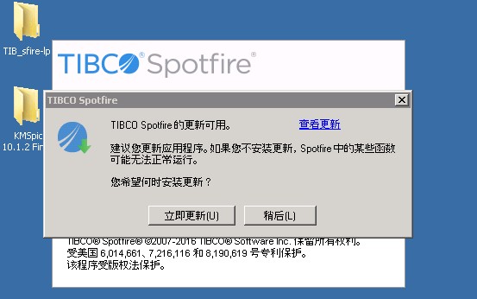

# 设置Cognitive Search Server Url

如下图所示步骤：

1、在Spotfire的菜单栏点击“工具”栏中的“管理器”（红色箭头1所指）；

2、点选“偏好”（红色箭头2所指）；

3、在左边栏点选展开“Everyone” （红色箭头3所指）；

4、在中间栏点选展开“Attivio”，点选“SearchUI Server URL” （红色箭头4所指），点击“编辑”按钮；

5、检查“AttivioServerUrl”项（红色箭头5所指），点击“确定”，然后点击“关闭”。

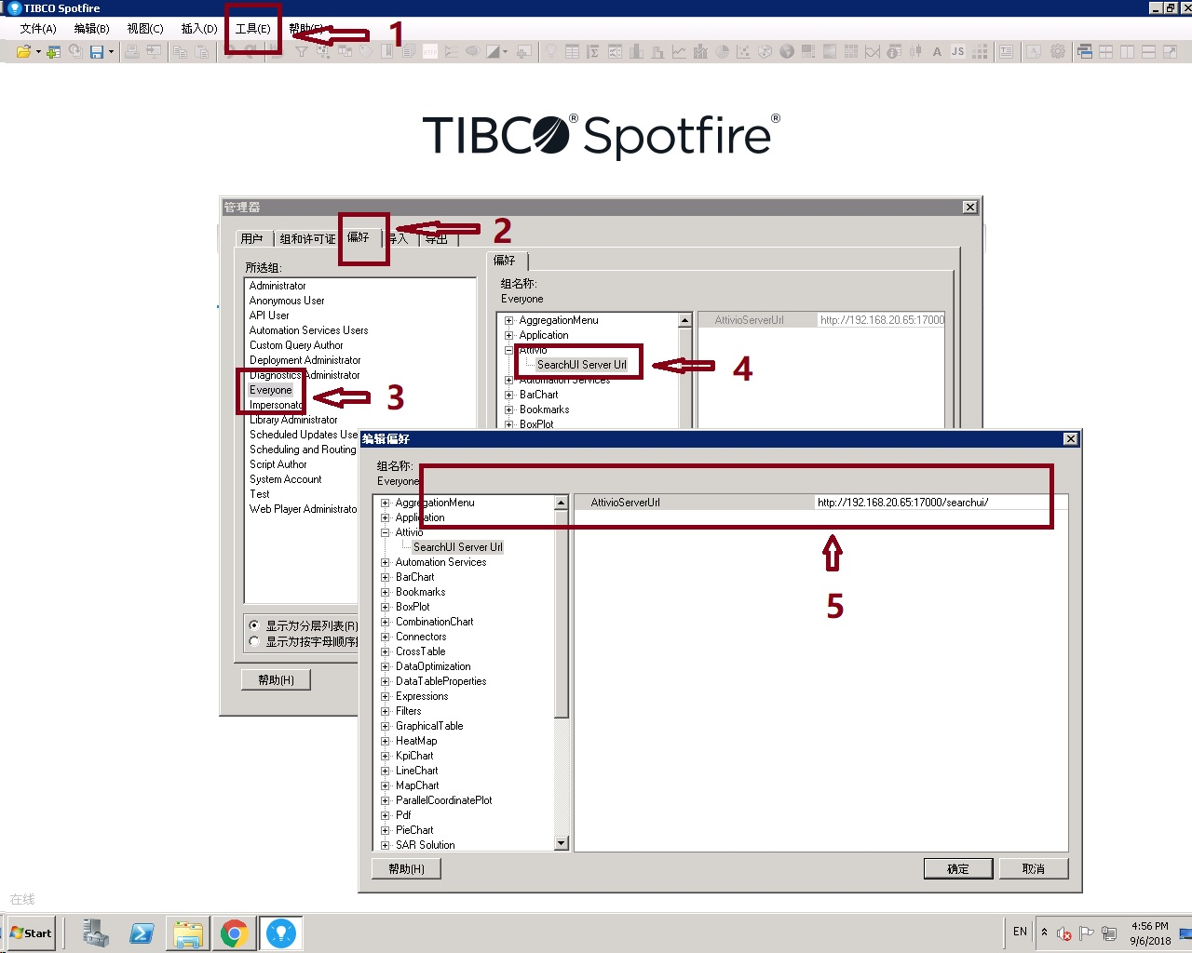

# Cognitive Search

如下图所示：

1、单击工具栏上的“A”按钮（红色箭头所指），显示“Cognitive Search”页面；

2、在“Cognitive Search”页面，输入账号、密码，点击“LOG IN”登录，登录成功显示搜索栏；

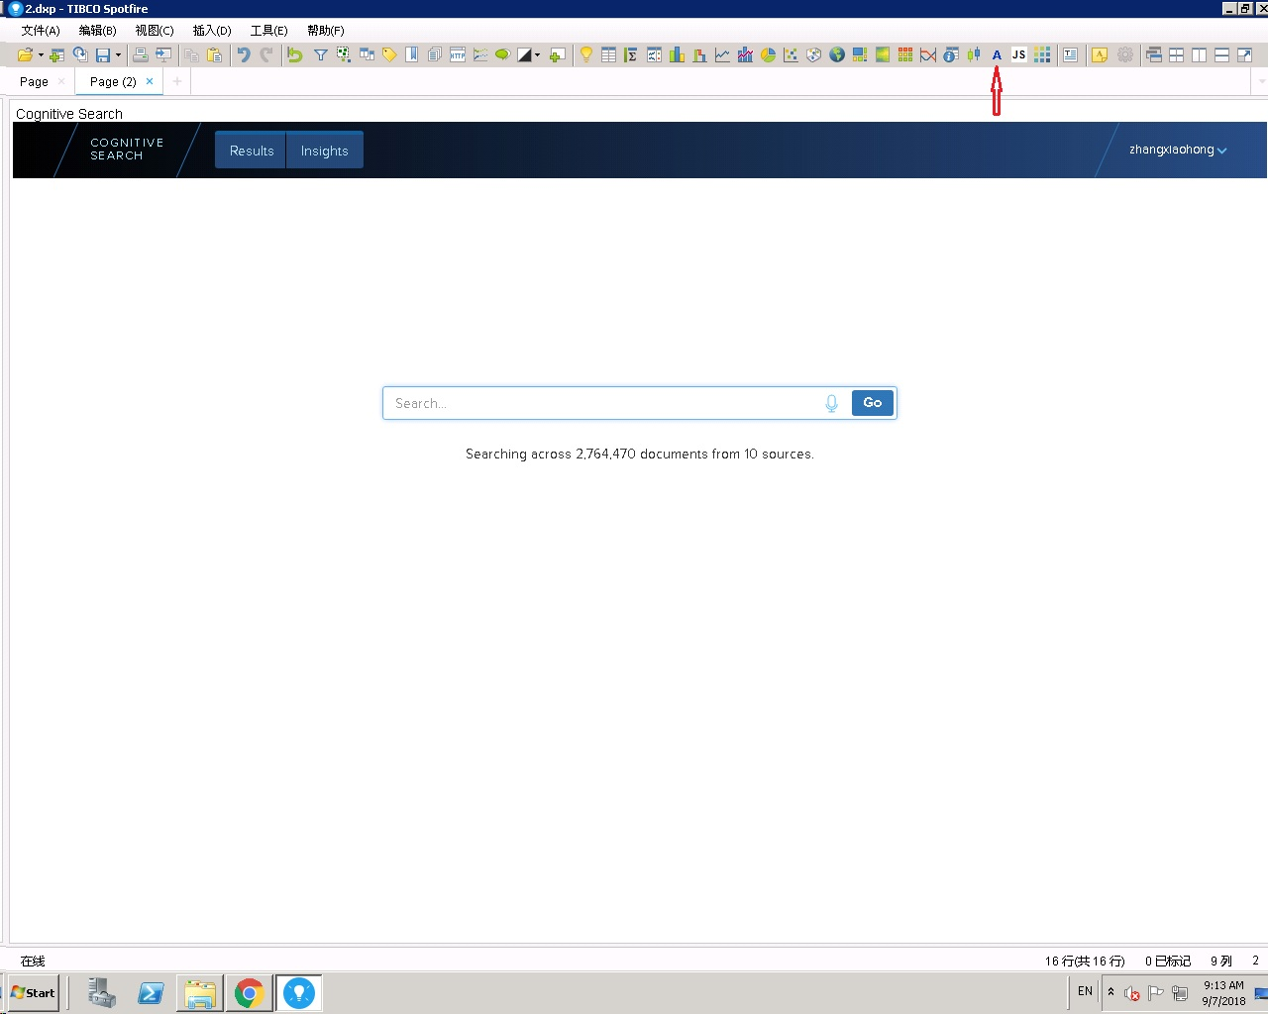

3、在搜索栏输入要搜索的词条，点击“Go”搜索，搜索结果如下图所示：

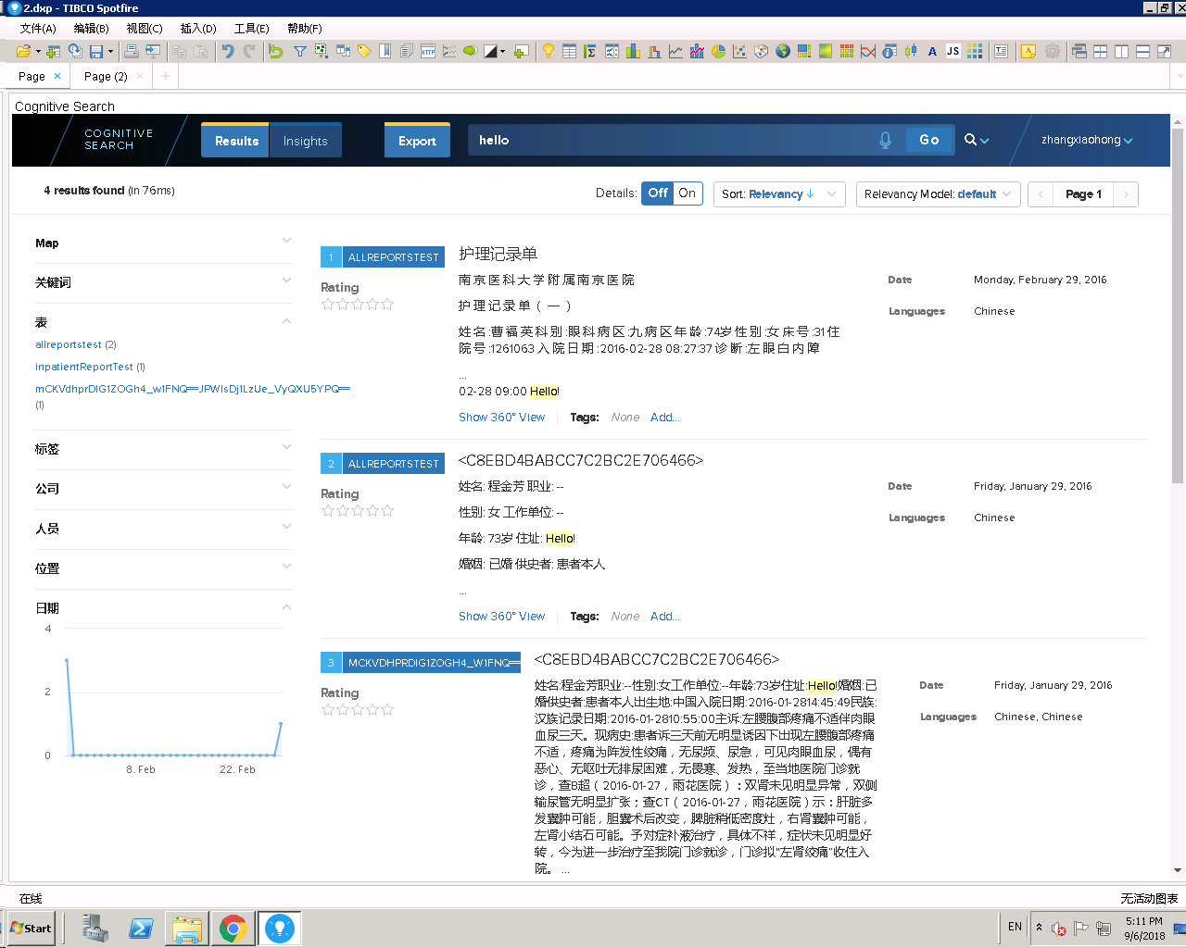

# 导出查询结果到Spotfire

如下图所示步骤：

1、单击“Cognitive Search”搜索结果的“Export”按钮（红色箭头1所指） ；

2、在“数据表”中会生成一个表名为“CognitiveSearch”的数据表（红色箭头2所指）。

